1. Inclusion Criteria:
   1. All services are included, including those that are NOT reported via CCS 3, where ClientVisit.rev_timein is within the report period.
   2. Services for test (ZEXCLUDE) and deleted consumers are excluded.
2. Fields:
   1. **COMP**
      1. Hard coded
   2. **CASE**
      1. ClientVisit.client_id
      2. Should it match CCS 3 by also including the external_id and padding it with leading zeros if necessary? Randy Love at MTM Services said that it doesn’t need to match CCS 3 and to only use the client_id. At the 10/26/2018 DMC meeting, Allen Wass at DBHDS requested that a faux Consumer ID be used for SPQM.
   3. **AlternateID**
      1. Blank – Empty String (“”)
      2. PLACEHOLDER ONLY – Do not populate until further notice.
   4. **DOB**
      1. Clients.dob
   5. **Gender**
      1. Clients.sex
      2. “01” = “F” (Female)   
         “02” = “M” (Male)   
         “98” (Not Collected (Not asked)) is the default.
      3. 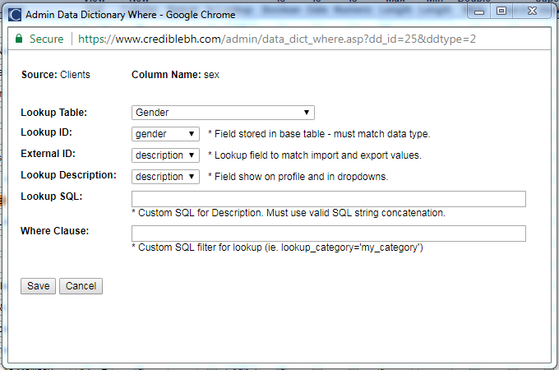
      4. SELECT * FROM Gender  
         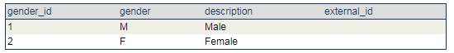
   6. **DIV**
      1. Programs.export_program_code
   7. **UNITNo**
      1. ClientVisit.program_id
   8. **UNIT**
      1. Programs.program_desc
   9. **SUBUNITNo**
      1. Blank – Empty String (“”)
   10. **SUBUNIT**
       1. Blank – Empty String (“”)
   11. **SERVER**
       1. ClientVisit.emp_id
       2. Should it match CCS 3 by also including the external_id and padding it with leading zeros if necessary? Randy Love at MTM Services said that it doesn’t need to match CCS 3 and to only use the emp_id.
   12. **LAST**
       1. Employees.last_name
   13. **FIRST**
       1. Employees.first_name
   14. **STAFFTYPE**
       1. Employees.credentials
   15. **SVCODE**
       1. ClientVisit.visittype_id
       2. Should ClientVisit.clientvisit_id be used instead?
   16. **SERVICE**
       1. VisitType.description
   17. **DATE**
       1. ClientVisit.rev_timein (Date Part)
   18. **START**
       1. ClientVisit.rev_timein (Time Part)
   19. **STOP**
       1. ClientVisit.rev_timeout (Time Part)
   20. **CLIENTTIME**
       1. ClientVisit.duration
   21. **APPT**
       1. Based upon Planner.visit_status, values are hard coded as follows:  
          “01” = “ARRIVED”  
          “02” = “CANCELLED”  
          “03” = “CNCLD BY PROV”  
          “04” = “CNCLD>24hr”  
          “05” = “COMPLETED”  
          “06” = “EMERGENCY”  
          “07” = “NON-CLIENT”  
          “08” = “NOSHOW”  
          “09” = “NOTPRESENT”  
          “10” = “RESCHEDULE”  
          “11” = “SCHEDULED”  
          “12” = “WALK-IN”  
          Blank – Empty String (“”) is the default.
       2. Is there a lookup table in Credible for the Schedule Status?
       3. Should data from the Cancellation/No Show form be included (see Region Ten’s form below)? It’s possible that not every CSB uses a Cancellation/No Show form. And, for the CSBs that do use a Cancellation/No Show form, each one is going to be different. So for these reasons including the data from the Cancellation/No Show form would make it difficult to compare data across CSBs.  
          1. 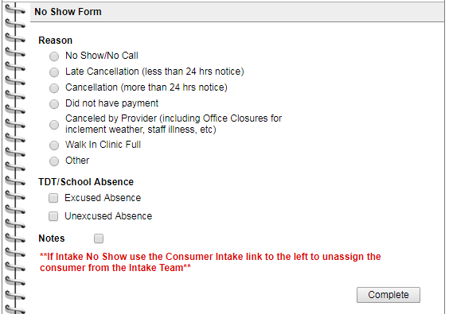
   22. **APPOINTMENT**
       1. Planner.visit_status
   23. **MDCD**
       1. “Y” (Yes) if the consumer had at least one payer/insurance policy that was active ***at any point*** within the report period where Z_PayerType.payertype_code = “03” (Medicaid), “10” (Medicaid Managed Care), “11” (Medicare Medicaid Dual Eligible), or “12” (Medicaid Governor’s Access Plan (GAP).
       2. “N” (No) is the default.
       3. 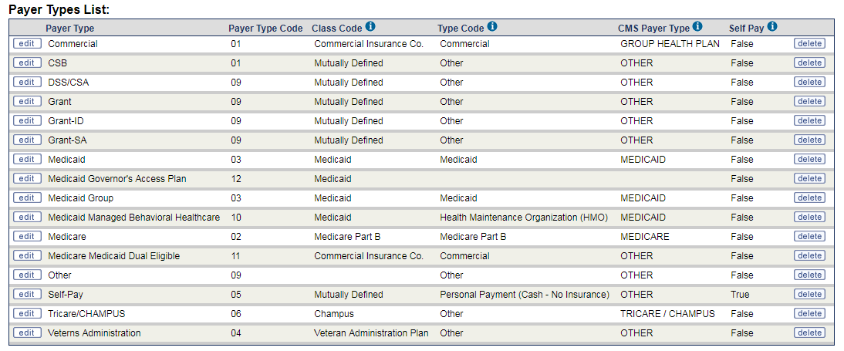
   24. **CPT**
       1. ClientVisit.cptcode
       2. Modifiers are NOT included.
   25. **PAYORBILLED**
       1. Z_PayerType.payertype_code associated with ClientVisitBilling.pri_payer_id
       2. “96” (Not Applicable) is the default for **non-billable** services.   
          “98” (Not Collected (Not asked)) is the default for **billable** services.
   26. **SUPERVISOR**
       1. Last Name, First Name of the first (alphabetically) supervisor assigned to the SERVER (ClientVisit.emp_id) in the EmployeeSupervisor table where is_indirect = 0 (False).
   27. **DX1 – DX8**
       1. Should the diagnoses linked/attached to the service or those found in the consumer’s Problem List be used?
       2. **DX1**
          1. ClientVisit.axis_code
       3. **DX2**
          1. ClientVisit.axis_code2
       4. **DX3**
          1. ClientVisit.axis_code3
       5. **DX4**
          1. ClientVisit.axis_code4
       6. **DX5**
          1. ClientVisit.axis_code5
       7. **DX6**
          1. Blank – Empty String (“”)
       8. **DX7**
          1. Blank – Empty String (“”)
       9. **DX8**
          1. Blank – Empty String (“”)
   28. **EnhancedCM**
       1. “Y” (Yes – Meets Criteria for ECM) if the consumer had a 923 active episode/open TOC record ***at any point*** within the report period.
       2. “N” (No – Does NOT meet Criteria for ECM) if the consumer did NOT have a 923 active episode/open TOC record ***at any point*** within the report period but did have a 920 active episode/open TOC record ***at any point*** within the report period.
       3. “A” (Not Applicable) is the default.